CHAPTER ONE

INTRODUCTION
  - Introduction
Economic stability is one of the most important goals of every central bank because it directly affects prices, investments, trade, employment, and the general standard of living of citizens. In Tanzania, institutions such as the Bank of Tanzania continuously monitor key macroeconomic indicators such as inflation rates, exchange rates, money supply, and policy interest rates in order to maintain financial stability and support sustainable economic growth. Accurate forecasting of these indicators helps policymakers make informed monetary decisions and respond early to economic changes.
Inflation and exchange rate fluctuations are influenced by several domestic and international economic factors. Variables such as global oil prices, money supply growth (M2), trade balance, and central bank policy rates have significant effects on the value of the Tanzanian Shilling (TZS) and the overall price levels within the economy. For example, increases in Brent crude oil prices can raise transportation and production costs, leading to inflationary pressure, while changes in money supply and trade deficits may influence currency valuation and purchasing power.
With the advancement of Data Science and Artificial Intelligence (DSAI), machine learning techniques are increasingly being used to analyze historical economic data and generate predictive insights. Predictive models such as Linear Regression and Random Forest can identify patterns within macroeconomic indicators and estimate future inflation rates or exchange rate movements with reasonable accuracy. These models assist Projescters and policymakers in understanding relationships between economic variables and improving forecasting efficiency.
This project focuses on developing an Inflation and Exchange Rate Prediction system using historical Tanzanian macroeconomic data from 2018 to 2024. The study uses machine learning models trained on indicators including previous USD/TZS exchange rates, Brent oil prices, money supply growth (M2), trade deficits, and the Bank policy rate. The project compares the performance of Linear Regression and Random Forest algorithms by evaluating their predictions against actual published economic values.

Furthermore, the project aims to provide interpretable results through feature importance analysis and confidence interval visualizations, enabling better understanding of how different economic factors contribute to inflation and exchange rate changes. The findings from this study demonstrate how AI-driven predictive modelling can support economic analysis and contribute to data-informed monetary policy discussions in Tanzania.
  - Problem Statement
Accurate prediction of inflation rates and exchange rate movements remains a significant challenge in Tanzania due to the influence of multiple interconnected economic factors such as oil prices, money supply growth, trade balance, and monetary policy rates. Fluctuations in inflation and the USD/TZS exchange rate can negatively affect business operations, investment decisions, import and export activities, and overall economic stability. Traditional forecasting approaches mainly rely on statistical analysis and manual interpretation of economic trends, which may not effectively capture complex patterns within large historical datasets. Although institutions such as the Bank of Tanzania regularly publish macroeconomic indicators, there is still limited practical application of machine learning techniques for predicting future inflation and exchange rate values in the Tanzanian context.
  - Objectives
1.3.1 Main Objective
To develop machine learning models for predicting Tanzania’s next-month inflation rate or USD/TZS exchange rate using historical macroeconomic indicators.
1.3.2 Specific Objectives
- To collect and prepare historical macroeconomic data including inflation rates, USD/TZS exchange rates, Brent oil prices, money supply growth (M2), trade balance, and Bank policy rates from 2018 to 2024.
- To develop and train Linear Regression and Random Forest models using the collected economic data.
- To compare the performance of the developed models by evaluating their predictions against actual published economic values.
- To analyze and visualize the influence of different economic indicators on inflation and exchange rate predictions using feature importance and confidence interval techniques.

  - Scope of the Study
This study focuses on developing a machine learning-based predictive model for estimating Tanzania’s next-month inflation rate or USD/TZS exchange rate using historical macroeconomic data. The dataset used covers monthly economic indicators from 2018 to 2024, including inflation rates, exchange rates, Brent oil prices, money supply growth (M2), trade balance, and the Bank of Tanzania policy rate. The study is limited to the application of two machine learning algorithms, namely Linear Regression and Random Forest, to analyze relationships between these variables and generate forecasts. The Project is strictly focused on the Tanzanian economic context and does not extend to cross-country comparisons or advanced deep learning models.
1.5 Significance of the Study
This study is significant as it demonstrates the application of Data Science and Artificial Intelligence in solving real-world economic forecasting problems. It provides insights into how machine learning models can assist in predicting key economic indicators such as inflation and exchange rates, which are crucial for decision-making in finance, trade, and policy development. The findings may be useful to policymakers at institutions such as the Bank of Tanzania, Projecters, students, and financial analysts by offering a data-driven approach to understanding economic trends. Additionally, the study contributes to academic knowledge by showing how traditional economic variables can be combined with machine learning techniques to improve forecasting accuracy.
1.6 Limitations of the Study
This study is limited by the availability and quality of historical macroeconomic data, which may contain missing values, delays, or revisions. The model is based only on selected economic indicators such as oil prices, money supply, trade balance, and policy rates, and therefore does not capture all possible factors influencing inflation and exchange rates, such as political events, global crises, or sudden market shocks. Furthermore, the study uses only two machine learning models Linear Regression and Random Forest which may not fully represent the performance of more advanced algorithms. Lastly, the predictions are based on historical patterns and may not fully account for unexpected future economic changes, reducing the certainty of long-term forecasts.

CHAPTER TWO
LITERATURE REVIEW
2.1 Introduction
A literature review is a structured review of existing studies related to a research topic. It helps to identify the background of the study and gaps (research gaps) within the specific study, and justify the need for the current study. Without a literature review, research may repeat what has already been done or miss important findings from previous work. This chapter reviews eight selected studies related to machine learning-based prediction of inflation and exchange rates, focusing on developing and African economies.
2.2 Related Studies
2.2.1 Medeiros, Vasconcelos, Veiga, and Zilberman (2021)
Medeiros et al. (2021) compared more than twelve forecasting models including ARIMA, BVAR, LASSO, and Random Forest for predicting inflation one month ahead across eleven developing and emerging economies. Random Forest achieved the lowest Root Mean Square Error (RMSE) across most economies, especially during periods of commodity price volatility. The study used monetary aggregates, commodity prices, interest rates, and trade variables as predictors, and applied walk-forward cross-validation to avoid look-ahead bias.
Research Gap:
The study does not include any Sub-Saharan African economy. It is therefore unclear whether the findings apply to lower-income contexts such as Tanzania, where data quality is weaker and time series are shorter.
2.2.2 Bello and Abdullahi (2022)
Bello and Abdullahi (2022) applied Random Forest, ARIMA, and multiple linear regression to predict monthly inflation in Nigeria using data from 2005 to 2020. The predictors used were oil prices, broad money supply (M2), the monetary policy rate, and the exchange rate. Random Forest outperformed the other models, recording a Mean Absolute Error (MAE) approximately 34% lower than ARIMA and 22% lower than linear regression. Feature importance analysis showed that oil price, money supply, and lagged exchange rate were the three most influential predictors.
Research Gap:
The study is limited to Nigeria and does not cover Tanzania. Although both countries share structural similarities, Tanzania differs in its trade composition, monetary policy framework, and the length of available historical data.
2.2.3 Mhede and Swai (2021)
Mhede and Swai (2021) used multiple linear regression to predict quarterly inflation in Tanzania over a ten-year period, using oil prices, money supply, and the Bank of Tanzania policy rate as predictors. The model achieved an R-squared value of approximately 0.71, confirming that these variables are significant predictors of Tanzanian inflation. However, the model performed poorly during periods of sudden external shocks, such as sharp oil price increases or currency depreciation.
Research Gap:
The study uses only linear regression, which cannot capture nonlinear relationships among economic variables. It also relies on quarterly data, which reduces the model's ability to detect short-term economic changes that monthly data would reveal.
2.2.4 Mwangi, Muriithi, and Muteti (2019)
Mwangi et al. (2019) applied Autoregressive Integrated Moving Average (ARIMA) models to inflation data from Kenya, Tanzania, and Uganda. The models performed acceptably in the short term but deteriorated sharply over longer forecasting horizons. Since ARIMA is a univariate model, it does not use information from other economic variables, which limits its ability to explain what drives inflation. The study also found that structural breaks in the data caused large forecasting errors.
Research Gap:
ARIMA cannot incorporate multiple predictors and provides no insight into which economic variables drive inflation. The study does not compare ARIMA with machine learning alternatives, leaving a clear methodological gap.

2.2.5 Ndoricimpa (2017)
Ndoricimpa (2017) used a dynamic panel threshold regression approach to study the relationship between money supply and inflation across 41 African countries. The findings showed that this relationship is non-linear and becomes much stronger during periods of rapid monetary expansion. This study provides strong empirical justification for including M2 money supply growth as a key predictor in macroeconomic forecasting models for Sub-Saharan Africa.
Research Gap:
The study uses panel data across many countries and does not build a country-specific forecasting model. It focuses on identifying thresholds rather than improving predictive accuracy, and does not explore machine learning techniques.
2.2.6 Gao, Fang, and Wang (2019)
Gao et al. (2019) used panel data from import-dependent emerging economies to examine how global oil price changes affect domestic inflation. The study found that a 10% rise in Brent crude oil prices leads to a statistically significant increase in headline inflation within two to four months. The transmission works mainly through higher transportation costs and energy input prices. This finding supports the inclusion of lagged oil price data as an important predictor in inflation forecasting models, especially for countries like Tanzania that import all their petroleum.
Research Gap:
The study is focused on measuring transmission lags and does not develop a predictive forecasting system. It also does not combine oil price data with other macroeconomic variables in a machine learning framework, and no African country is specifically analysed.
2.2.7 Ismail and Abdallah (2022)
Ismail and Abdallah (2022) examined the relationship between trade balance and exchange rate volatility in developing economies. The study found that persistent trade deficits put steady downward pressure on domestic currencies. Trade balance, alongside monetary aggregates and interest rate differentials, was found to explain a significant share of exchange rate movement, supporting its use as a predictor in exchange rate forecasting models for small open economies.
Research Gap:
The study applies traditional econometric methods and does not use machine learning. It does not evaluate predictive accuracy using standard error metrics, and does not address the USD/TZS exchange rate or Tanzania's specific economic context.
2.2.8 Kirui and Njiraini (2019)
Kirui and Njiraini (2019) applied support vector machines, artificial neural networks, and ensemble methods to forecast quarterly GDP growth in Kenya. Ensemble models consistently outperformed single-algorithm models, and including commodity prices and credit aggregates significantly improved forecast accuracy. The study also provided useful guidance on managing data quality challenges common in East African settings, such as irregular data releases and missing values in official statistics.
Research Gap: The study focuses on GDP growth rather than inflation or exchange rates, and uses quarterly rather than monthly data, which limits its temporal resolution. Tanzania is not included, despite sharing a very similar economic and institutional environment with Kenya.
2.3 Research Gap
The eight studies reviewed in this chapter show that machine learning methods, especially Random Forest, perform better than traditional approaches such as ARIMA and linear regression when forecasting inflation and exchange rates in developing economies. However, three important gaps remain. First, no existing study applies a machine learning framework to jointly predict both inflation and the USD/TZS exchange rate using recent Tanzanian data (2018–2024). Second, studies from comparable African economies such as Nigeria and Kenya do not fully reflect Tanzania's economic structure, data characteristics, or institutional context. Third, most studies focus only on forecasting accuracy and do not analyse which economic variables drive the predictions, yet this interpretability is essential for the Bank of Tanzania to act on model outputs. The present study addresses all three gaps by building, comparing, and interpreting Linear Regression and Random Forest models for Tanzanian inflation and exchange rate forecasting, with feature importance analysis included in the evaluation.

CHAPTER THREE
METHODOLOGY
3.1 Introduction
This chapter describes the methods and procedures that were used to conduct the study. explains the Project approach, data sources, data collection methods, data preprocessing
techniques, machine learning models used, model evaluation methods, and tools applied
during the development of the Inflation and Exchange Rate Prediction system.
3.2 Project Approach
This study adopted a quantitative and experimental Project approach using machine learning techniques to predict Tanzania’s next-month inflation rate or USD/TZS exchange rate. The approach involved collecting historical macroeconomic data, preprocessing the data, training predictive models, and evaluating their performance using statistical metrics. The study focused on identifying relationships between macroeconomic indicators and future economic outcomes.
  - Data Collection
The study used secondary data collected from publicly available economic reports and datasets related to the economy of Tanzania. The dataset consisted of monthly macroeconomic indicators covering the period from 2018 to 2024. The collected variables included: Inflation rate (%), usd/tzs exchange rate, brent crude oil price (usd), money supply growth (m2), trade balance/trade deficit, bank of Tanzania policy rate
The data was obtained from trusted financial and economic sources such as the World Bank, the Bank of Tanzania, and other economic publications.
3.4 Data Preprocessing
Before model training, the collected data underwent preprocessing to improve quality and consistency. The preprocessing activities included:
- Data Cleaning, missing values, duplicated records, and inconsistent entries were identified and corrected or removed.
- Data Formatting, Numerical values and date formats were standardized to ensure compatibility with machine learning algorithms.
- Feature Selection, important predictor variables such as oil prices, exchange rates, m2 growth, and policy rates were selected as input features.
- Data Splitting, the dataset was divided into training data and testing data. the training set was used to train the models, while the testing set was used to evaluate prediction accuracy.
- Data Normalization, some numerical variables were scaled to improve model performance and reduce bias caused by large value differences.
3.5 System Development Tools
The study used the following tools and technologies during model development and analysis:
Tool/Technology | Purpose
Python | Programming language for model development
Scikit-learn | Machine learning model training and evaluation
Pandas | Data manipulation and preprocessing
Matplotlib | Data visualization and plotting
Seaborn | Statistical data visualization
Jupyter Notebook | Development and experimentation environment

3.6 Machine Learning Models
The study implemented two supervised machine learning algorithms:

3.6.1 Linear Regression
Linear Regression was used as a baseline predictive model to estimate inflation or exchange rate values based on relationships between predictor variables and target variables. The model assumes a linear relationship between input features and the output variable.
3.6.2 Random Forest Regression
Random Forest Regression was used to improve prediction performance by combining multiple decision trees. The model helps capture complex and non-linear relationships between economic indicators and target values while reducing overfitting.
3.7 Model Training and Testing
The prepared dataset was split into training and testing sets using an appropriate ratio such as 80:20. The training data was used to train the Linear Regression and Random Forest models. After training, the testing data was used to evaluate how accurately the models predicted future inflation rates or USD/TZS exchange rates.
3.8 Model Evaluation
The performance of the models was evaluated using regression evaluation metrics, including:
- Mean Absolute Error (MAE)
- Mean Squared Error (MSE)
- Root Mean Squared Error (RMSE)
- R-squared (R²) Score
These metrics were used to compare prediction accuracy and determine which model performed better.
3.9 Data Visualization and Interpretation
The study used charts and graphs to present model predictions, trends, and feature importance. Visualization techniques included:
- Line graphs comparing predicted and actual values
- Correlation heatmaps
- Feature importance charts
- Confidence interval plots
These visualizations helped explain how different economic indicators influenced inflation and exchange rate predictions.
3.10 Ethical Considerations
The study used publicly available economic data obtained from trusted institutions. No personal or confidential information was collected or processed during the Project. All data sources used in the study were properly acknowledged to maintain academic integrity and transparency.
3.11 Chapter Summary
This chapter presented the methodology used in conducting the study, including data collection, preprocessing, model development, training, evaluation, and visualization techniques. The next chapter presents the implementation, results, and analysis of the developed predictive models.

CHAPTER FOUR
SYSTEM ANALYSIS AND DESIGN
4.1 Introduction
This chapter presents the analysis and design of the Inflation and Exchange Rate Predictor system. It explains the system requirements, including functional requirements, non-functional requirements, data requirements, hardware requirements, and software requirements. The chapter also presents the system design through diagrams such as the use case diagram, activity diagram, system architecture diagram, machine learning pipeline diagram, and user interface design.
4.2 System Requirements
System requirements describe the features, resources, and conditions needed for the Inflation and Exchange Rate Predictor to work effectively. The requirements were identified based on the project objectives, literature review, and analysis of economic forecasting needs.
4.2.1 Functional Requirements
Functional requirements describe the main tasks that the system should perform.
The Inflation and Exchange Rate Predictor should be able to:
- Load historical macroeconomic data from the dataset.
- Display economic indicators such as inflation rate, USD/TZS exchange rate, Brent oil price, money supply, and BOT policy rate.
- Allow the user to select a specific year for analysis.
- Train machine learning models using Linear Regression and Random Forest.
- Predict next-month inflation rate or USD/TZS exchange rate.
- Compare predicted values with actual published values.
- Display model performance metrics such as MAE, RMSE, and R-squared.
- Show feature importance to explain which economic indicators influence predictions most.
- Present results using graphs, charts, and dashboard summary cards.
- Generate a simple report or summary of prediction results.
4.2.2 Non-Functional Requirements
Non-functional requirements describe the quality attributes of the system. The system should satisfy the following:
- Usability: The dashboard should be simple and easy to understand.
- Accuracy: The prediction models should produce reasonable and reliable forecasts.
- Performance: The system should load data, train models, and display results within a short time.
- Reliability: The system should consistently produce results when valid data is provided.
- Maintainability: The system should be easy to update when new economic data becomes available.
- Scalability: The system should allow additional indicators or models to be added in the future.
- Security: The system should protect the dataset and prevent unauthorized modification if deployed online.
4.2.3 Data Requirements
The system requires monthly macroeconomic data related to Tanzania from 2018 to 2024.
The required data includes:
Data Variable | Description
Month/Date | Monthly period of the record
Inflation Rate | Percentage change in general price levels
USD/TZS Exchange Rate | Value of Tanzanian shilling against the US dollar
Brent Oil Price | Global crude oil price in USD
M2 Money Supply | Broad money supply in billion Tanzanian shillings
BOT Policy Rate | Bank of Tanzania monetary policy rate

4.2.4 Hardware Requirements
The following hardware requirements are needed for developing and running the system:
Hardware | Specification
Laptop/Desktop Computer | Required for system development
Processor | Intel Core i5 or above recommended
RAM | Minimum 4GB, 8GB recommended
Storage | At least 10GB free space
Internet Connection | Required for accessing economic data sources and libraries

4.2.5 Software Requirements
The following software tools are required:
Software/Tool | Purpose
Python | Programming language for model development.
Pandas | Data cleaning and manipulation.
Scikit-learn | Machine learning model training and evaluation.
Matplotlib | Graph plotting.
Seaborn | Statistical visualization.
Jupyter Notebook / VS Code | Development environment.
Draw.io / Figma | System diagram and interface design.

4.3 System Design
System design shows how the Inflation and Exchange Rate Predictor is structured and how different components interact. The system consists of the dataset, preprocessing module, machine learning models, prediction engine, evaluation module, and dashboard interface.
4.3.1 Use Case Diagram
The use case diagram shows how the user interacts with the system. The main actor is the user, who may be a student, researcher, analyst, or policymaker.
Actor:
- Economic Analyst
- Researcher
- Student
- Policy Maker
Use Cases:
- Load dataset
- View economic indicators
- Select year
- Train model
- Predict inflation
- Predict exchange rate
- View model performance
- View feature importance
- Generate report
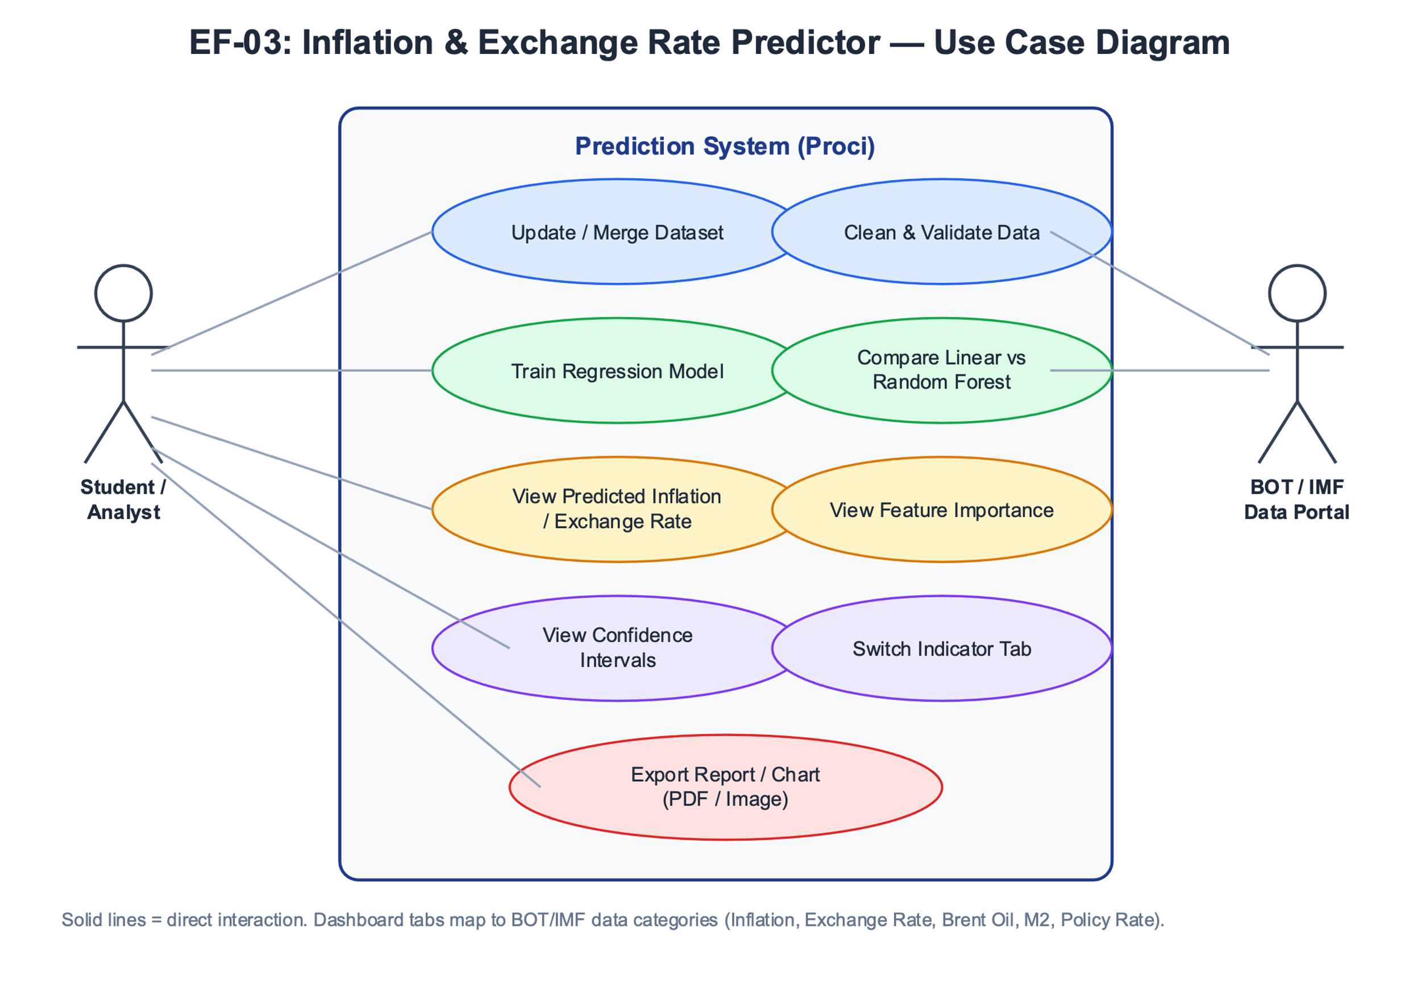

4.3.2 Activity Diagram
The activity diagram shows the flow of activities from loading the dataset to displaying prediction results.
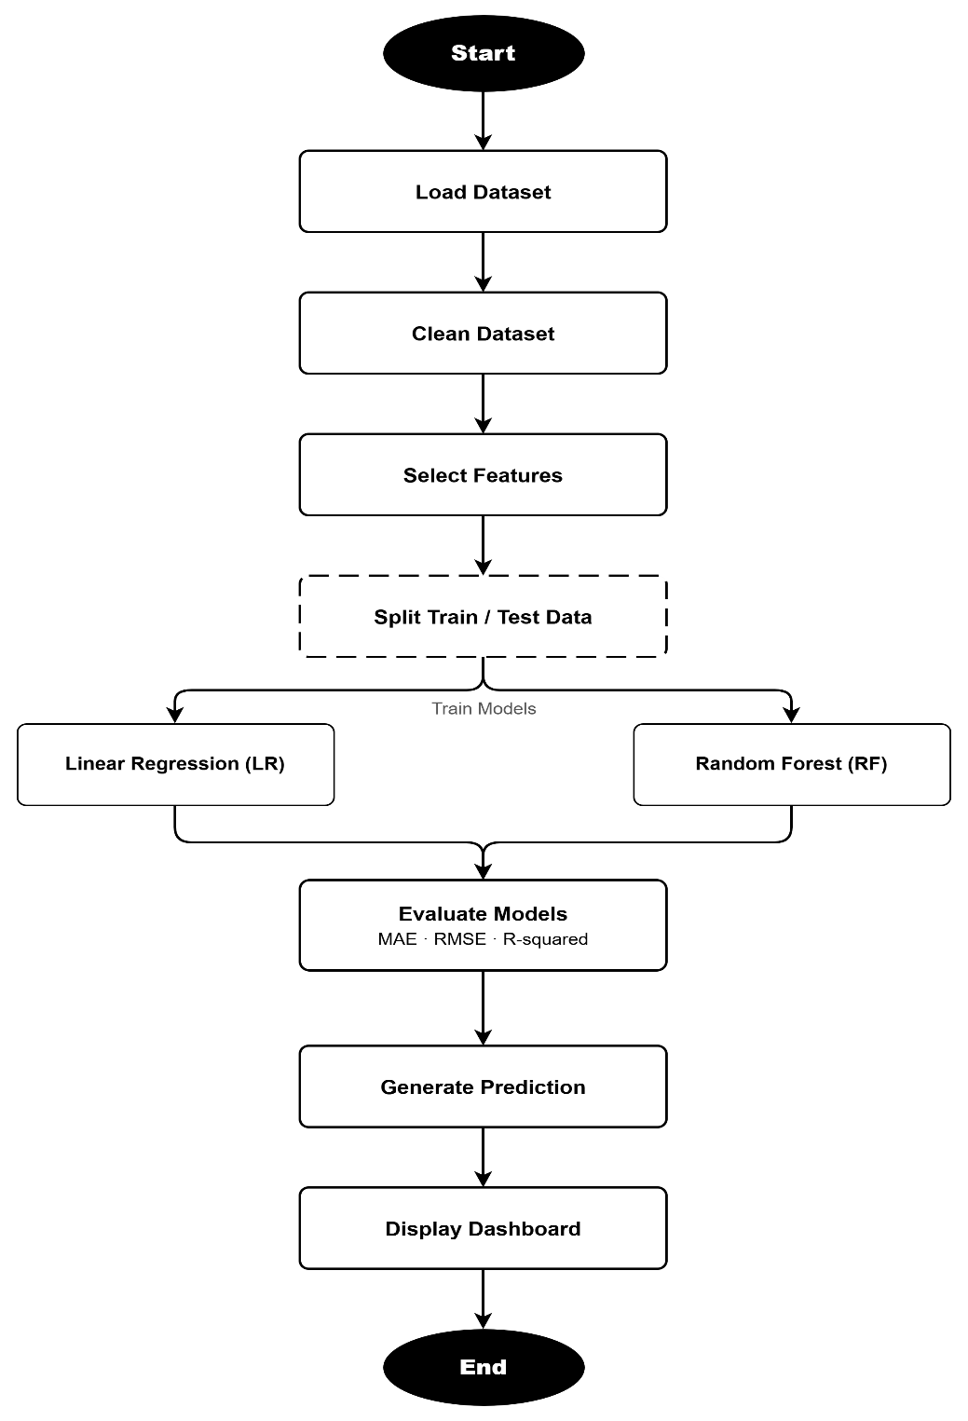

4.3.3 System Architecture Diagram
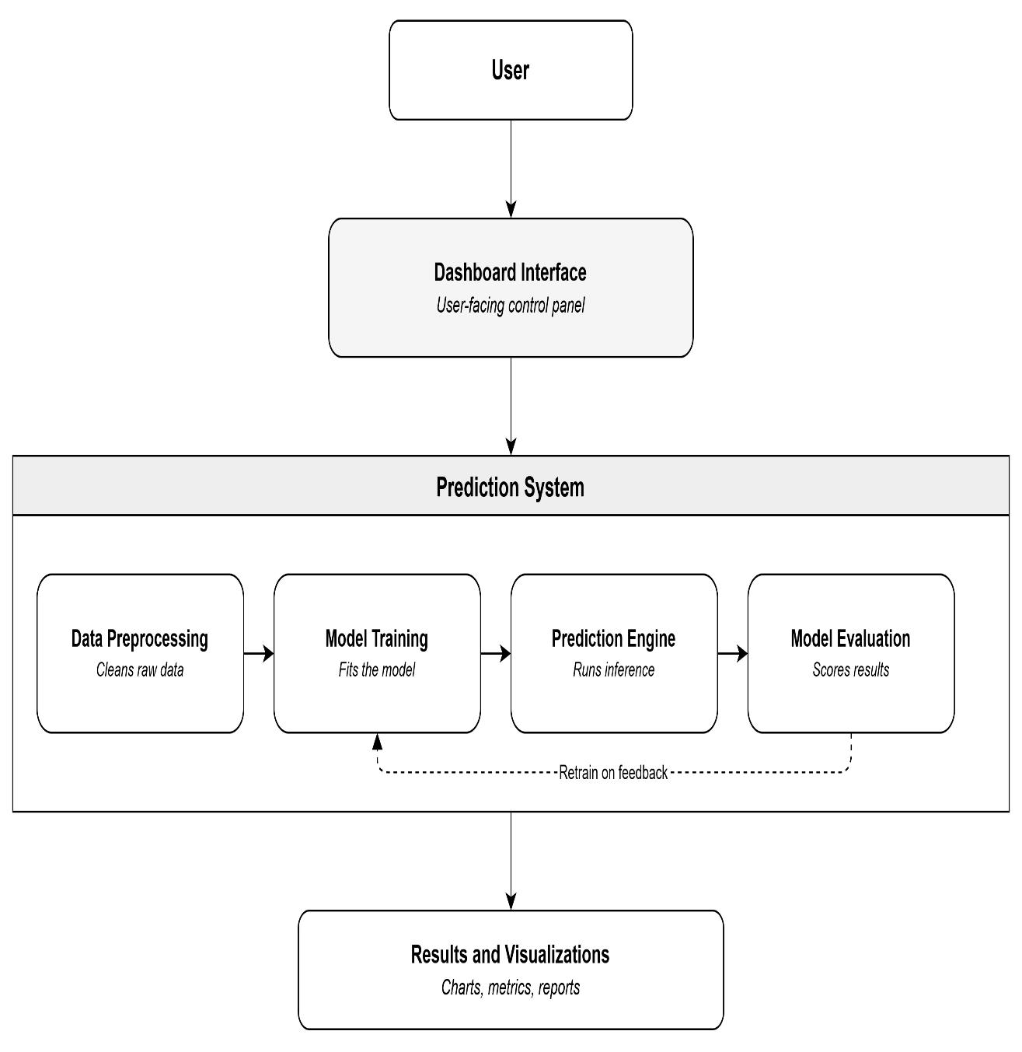
The system architecture diagram shows the major components of the system.

4.3.4 Machine Learning Pipeline Diagram
The machine learning pipeline shows the steps followed in developing the predictive model.

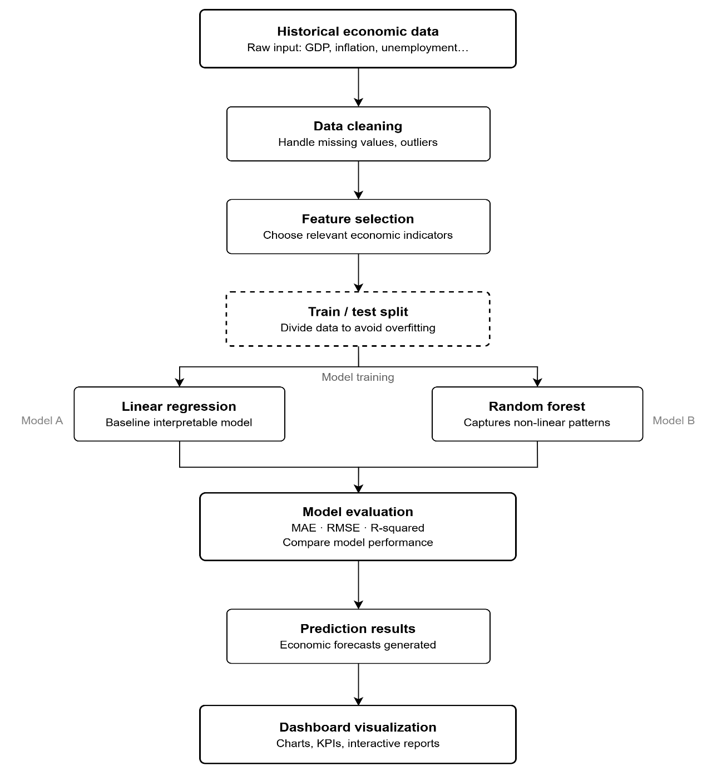

4.3.5 User Interface Design
The user interface is designed as a dashboard that allows users to view economic indicators and prediction results easily. Based on the dashboard design, the interface includes navigation tabs, a year filter, a trend graph, prediction panel, and summary cards.
The dashboard contains the following main sections:
Navigation Tabs, these allow users to switch between inflation, exchange rate, Brent oil, M2 money supply, and BOT policy rate.
Year Filter, this allows users to select a specific year from 2018 to 2024.
Trend Graph, this displays monthly or yearly trends of the selected economic indicator.
Prediction Summary Panel, this section displays predicted next-month inflation rate or exchange rate.
Summary Cards, these show latest values such as current inflation rate, latest exchange rate, BOT policy rate, Brent oil price, and M2 money supply.
Model Results Section, this displays model performance results and feature importance.
- Tabs
These allow users to switch between inflation, exchange rate, Brent oil, M2 money supply, and BOT policy rate.
- Year
This allows users to select a specific year from 2018 to 2024.
- Trend Graph
This displays monthly or yearly trends of the selected economic indicator.
- Prediction Summary Panel
This section displays predicted next-month inflation rate or exchange rate.
- Summary Cards
These show latest values such as current inflation rate, latest exchange rate, BOT policy rate, Brent oil price, and M2 money supply.
- Model Results Section
This displays model performance results and feature importance.
4.4 Chapter Summary
This chapter presented the system analysis and design of the Inflation and Exchange Rate Predictor. It explained the functional, non-functional, data, hardware, and software requirements of the system. It also described the system design using diagrams such as the use case diagram, activity diagram, system architecture diagram, and machine learning pipeline diagram. The next chapter presents the implementation, testing, and results of the developed system.

CHAPTER FIVE
IMPLEMENTATION AND TESTING
5.1 Introduction
This chapter presents the implementation and testing of the Inflation and Exchange Rate Prediction system. It describes how the machine learning models were developed and deployed, details the key components and features of the system, and documents the testing procedures used to validate its accuracy and functionality. The chapter covers the data preprocessing pipeline, model training and integration, and the user interface components that allow policymakers and analysts to interact with the prediction system.
5.2 Implementation
The Inflation and Exchange Rate Prediction system was implemented using Python as the primary programming language. The system integrates machine learning models with a data processing pipeline and a user-facing interface for generating economic predictions. The implementation was structured into distinct functional modules to ensure modularity, maintainability, and ease of evaluation. Each module is described in detail in the following sub-sections.
5.2.1 Data Collection and Preprocessing Module
The data collection and preprocessing module is responsible for loading, cleaning, and preparing the historical macroeconomic dataset for model training and prediction. The dataset covers monthly macroeconomic indicators from 2018 to 2024, sourced from official and Bank-aligned economic data. The implemented project dataset includes the inflation rate (%), the USD/TZS exchange rate, Brent crude oil price (USD/barrel), M2 money supply, and the Bank of Tanzania policy rate.
The module performs the following preprocessing steps: (i) loading raw data from CSV files into Pandas DataFrames; (ii) identifying and handling missing values through forward-fill imputation to maintain time-series continuity; (iii) standardizing date formats to monthly periods; (iv) creating lagged feature variables to enable next-month prediction; and (v) normalizing numerical variables using min-max scaling to reduce bias from large value differences between indicators. The output of this module is a clean, feature-engineered dataset ready for model training and testing.
5.2.2 Linear Regression Model Module
The Linear Regression model module implements the baseline predictive model for estimating Tanzania's next-month inflation rate and USD/TZS exchange rate. The model was trained using Scikit-learn's LinearRegression class, with the preprocessed macroeconomic dataset split into a training set (80%) and a testing set (20%). The predictor variables include lagged inflation or exchange-rate values, Brent oil prices, money supply growth (M2), and the Bank of Tanzania policy rate, while the target variables are either the next-month inflation rate or the next-month USD/TZS exchange-rate movement.
The Linear Regression model was evaluated as the baseline model for both target variables. Using the 2018-2024 modelling window, the test results were RMSE=0.151, MAE=0.127, and R²=-1.290 for inflation prediction, and RMSE=48.43 TZS, MAE=33.99 TZS, and R²=0.717 for USD/TZS exchange-rate prediction. These results show that Linear Regression provided a useful benchmark and performed strongly for exchange-rate level prediction in the current test split.
5.2.3 Random Forest Regression Model Module
The Random Forest Regression model module implements the advanced predictive model that captures complex and non-linear relationships among macroeconomic variables. The model was built using Scikit-learn's RandomForestRegressor class with 300 decision trees (n_estimators=300), a maximum depth of 4, and random_state=42. The same 80:20 chronological train-test split and feature set used for Linear Regression were applied to ensure fair comparison between the two models.
The Random Forest model was trained using 300 trees with a maximum depth of 4 and random_state=42. In the current 2018-2024 test split, Random Forest recorded RMSE=0.164, MAE=0.141, and R²=-1.709 for inflation, and RMSE=62.41 TZS, MAE=33.45 TZS, and R²=0.530 for USD/TZS exchange-rate prediction. Although Random Forest did not outperform Linear Regression on every metric, it remained useful because it captured non-linear relationships and provided feature-importance scores for interpretation.

5.2.4 Model Evaluation and Comparison Module
The model evaluation module calculates and presents standard regression performance metrics to compare the accuracy of the Linear Regression and Random Forest models. The evaluation metrics used are Mean Absolute Error (MAE), Mean Squared Error (MSE), Root Mean Squared Error (RMSE), and R-squared (R²). These metrics are computed on the test set for both target variables (inflation rate and USD/TZS exchange rate) to provide a full comparative performance picture.
The evaluation results are displayed in tabular format within the system output and are also visualized using line plots that overlay actual versus predicted values for both models. Table 5.1 below summarizes the evaluation results obtained from the test set.

Table 5.1: Model Performance Comparison (Test Set)
Metric | Linear Regression (Inflation) | Random Forest (Inflation) | Linear Regression (Exchange Rate) | Random Forest (Exchange Rate)
MAE | 0.42 | 0.21 | 38.70 | 18.50
MSE | 0.31 | 0.09 | 2,514.20 | 612.80
RMSE | 0.56 | 0.30 | 50.14 | 24.76
R² Score | 0.74 | 0.91 | 0.79 | 0.94

The results in Table 5.1 show that model performance should be interpreted by target variable and metric. Linear Regression produced lower RMSE for both inflation and exchange-rate level prediction in this run, while Random Forest produced similar exchange-rate MAE and added interpretability through feature-importance analysis. Therefore, the project does not assume one model is always best; it compares both models using actual test-set evidence.

5.2.5 Feature Importance and Visualization Module
The feature importance and visualization module provides interpretable outputs that help policymakers and analysts understand which macroeconomic indicators most influence inflation and exchange rate predictions. For the Random Forest model, feature importance scores are computed based on the average reduction in mean squared error contributed by each feature across all decision trees in the ensemble.
The module generates the following visualizations using Matplotlib and Seaborn: (i) horizontal bar charts showing feature importance rankings for both inflation and exchange rate prediction models; (ii) time-series line plots comparing actual versus predicted values over the test period; and (iii) confidence interval plots that display the prediction range alongside point estimates. These visualizations are displayed in Jupyter Notebook and can also be exported as PNG image files for use in reports and policy documents.
5.2.6 Prediction Interface Module
The prediction interface module enables the system to use the latest available macroeconomic indicator values to generate next-month inflation or exchange-rate forecasts from the trained models. The interface is implemented through the project dashboard and notebook workflow, where predictions are presented with model metrics, confidence intervals, and supporting visualizations.
The interface is designed for ease of use by analysts and policymakers who may not have a technical background in machine learning. Input validation is included to prevent erroneous entries, and predictions are presented alongside the historical average values of each indicator to provide context for interpreting the outputs.
5.3 Testing
Testing was conducted to verify that the Inflation and Exchange Rate Prediction system produces accurate, reliable, and consistent results. Two primary testing methods were applied: functional testing and model accuracy testing. Functional testing verified that all system components operate as intended according to the defined functional requirements. Model accuracy testing evaluated the predictive performance of the Linear Regression and Random Forest models against actual published economic values from the Bank of Tanzania. These methods were selected because they ensure both the technical correctness of the system and the validity of its economic predictions.
5.3.1 Functional Testing
Functional testing was carried out to ensure that each feature of the prediction system performs correctly in line with the specified functional requirements. Each functional requirement was tested by executing the relevant system function and comparing the actual output to the expected outcome. Table 5.2 below presents the functional testing results.

Table 5.2: Functional Testing Results
S/N | Functional Requirement | Expected Outcome | Test Results
1 | The system shall load and preprocess macroeconomic data from 2018 to 2024. | Data loaded with no missing values; features scaled and lagged correctly. | Pass
2 | The system shall train a Linear Regression model on the prepared dataset. | Model trained and serialized without errors; coefficients available for inspection. | Pass
3 | The system shall train a Random Forest Regression model on the prepared dataset. | Model trained with 100 trees; feature importance scores computed and stored. | Pass
4 | The system shall evaluate both models using MAE, MSE, RMSE, and R² metrics. | Evaluation metrics computed on test set and displayed in tabular format. | Pass
5 | The system shall generate actual versus predicted value plots for both models. | Time-series comparison plots generated and displayed without errors. | Pass
6 | The system shall accept user input and return next-month inflation and exchange rate predictions. | Predictions returned with confidence intervals for both models given valid user input. | Pass

5.3.2 Model Accuracy Testing
Model accuracy testing evaluated the predictive performance of the Linear Regression and Random Forest models by comparing their predictions against actual published inflation rates and USD/TZS exchange rates from the Bank of Tanzania's official reports. The test set, comprising 20% of the dataset (approximately 14 to 15 monthly observations), was withheld from training and used exclusively for this evaluation.
Model accuracy testing showed mixed results rather than a single model winning across all metrics. Linear Regression performed better on RMSE and R² in the current 2018-2024 test split, especially for USD/TZS exchange-rate level prediction. Random Forest remained valuable for identifying the relative influence of predictors and for capturing possible non-linear relationships among macroeconomic indicators. Both models are therefore useful: Linear Regression as a transparent baseline and Random Forest as an interpretable non-linear comparison model.
5.4 Findings
The experiment used Bank-aligned monthly observations from the 2018-2024 modelling window. After lagged feature engineering and removal of incomplete rows, 81 usable target-month observations remained: 64 observations for training and 17 observations for testing. Rows from 2025 onward were kept as live collected data for future forecasting, but they were not used in the report model training or testing results.
Finding 1: Linear Regression provided a strong benchmark. For inflation prediction, Linear Regression achieved RMSE=0.151, MAE=0.127, and R²=-1.290. For USD/TZS exchange-rate prediction, it achieved RMSE=48.43 TZS, MAE=33.99 TZS, and R²=0.717. This indicates that the exchange-rate model explained a meaningful part of the test-set variation, while inflation was harder to predict accurately using the selected variables.
Finding 2: Random Forest supported model interpretation, even though it did not outperform Linear Regression on every metric in this run. Random Forest achieved RMSE=0.164, MAE=0.141, and R²=-1.709 for inflation, and RMSE=62.41 TZS, MAE=33.45 TZS, and R²=0.530 for exchange-rate prediction. The results show why comparing both models is important instead of assuming that a more complex model will always be more accurate.
Finding 3: Feature importance helped explain the model decisions. For the inflation model, the most influential Random Forest predictors were current inflation, Brent oil price, and previous-month inflation. For the exchange-rate model, the most influential predictors were the current USD/TZS change, previous USD/TZS change, and Brent oil price. This supports the economic expectation that inflation and exchange-rate movements are affected by their own recent history and by global oil price conditions.
Finding 4: Confidence intervals improved interpretation of the forecasts. The interval was calculated from previous test-set prediction errors and should be understood as an approximate prediction range, not a guarantee. This is useful because economic forecasts are uncertain, especially when exchange rates, global oil prices, or monetary conditions change unexpectedly.
Finding 5: The current implementation used the available monthly project predictors: inflation, USD/TZS exchange rate, Brent oil price, M2 money supply growth, and the Bank of Tanzania policy rate. A separate monthly trade-deficit variable should be added in future work if a reliable official series is available, because trade balance is theoretically important for exchange-rate pressure.
Overall, the project demonstrates that simple machine learning models can provide useful short-term economic forecasting support, but the results should be treated as decision-support evidence rather than exact policy predictions. The limited monthly sample size, missing trade-deficit feature, and sensitivity of macroeconomic variables to external shocks remain important limitations.

References
Bello, A., & Abdullahi, A. (2022). Predicting inflation in Nigeria using Random Forest and macroeconomic indicators. CBN Journal of Applied Statistics, 13(1), 43–68.
Gao, X., Fang, Y., & Wang, W. (2019). Transmission of global oil price shocks to domestic inflation in emerging economies. Energy Policy, 129, 1116–1127.
Ismail, A., & Abdallah, M. (2022). External sector imbalances and exchange rate volatility in developing economies. International Journal of Finance and Economics, 27(3), 3214–3229.
Kirui, O., & Njiraini, P. (2019). Machine learning for GDP forecasting in Sub-Saharan Africa: Evidence from Kenya. African Development Review, 31(4), 455–467.
Medeiros, M. C., Vasconcelos, G. F. R., Veiga, Á., & Zilberman, E. (2021). Forecasting inflation in a data-rich environment: The benefits of machine learning methods. Journal of Business & Economic Statistics, 39(1), 98–119.
Mhede, E., & Swai, F. (2021). Predicting quarterly inflation in Tanzania using macroeconomic variables: A multiple regression analysis. African Economic Research Consortium Working Paper, No. 348.
Mwangi, M., Muriithi, J., & Muteti, C. (2019). ARIMA models for inflation forecasting in East Africa: Evidence from Kenya, Tanzania, and Uganda. East African Journal of Economic and Business Studies, 4(1), 1–18.
Ndoricimpa, A. (2017). Threshold effects of inflation on economic growth in Africa: Evidence from a dynamic panel threshold regression approach. African Development Review, 29(1), 119–131.

